Section 4(ii) & (iii) | Team Structure, Experience and Qualification of the Team
6.0 | Property Management Services Provider



  - Company Profile

China Overseas Holding Limited was established in Hong Kong in June 1979. It is a subsidiary of China State Construction Engineering Corporation Limited, with five listed companies in Hong Kong covering business areas such as real estate development and operation, construction and infrastructure investment, property services, etc. China Overseas Group has become the highest-rated real estate development and operation company in the mainland Chinese market, with the highest brand value and the largest single ownership office building scale. It is also the largest engineering contractor, the largest Chinese-funded real estate developer, and the largest public facilities property service provider in the Hong Kong and Macau regions. Currently, its total assets exceed 1.2 trillion yuan.


World-class Investment, Construction and Operation Service Provider
China Overseas Property Service Limited (COPSL), which was established in Hong Kong on December 23, 1986, is a wholly-owned subsidiary of China Overseas Holding Limited (Code: 2669) and with eight subsidiary companies in the region. We have a heritage of professional property management services provision since 1986 for our customers over Hong Kong and Macau. Our business covers ten major categories, including Central Government and Military Bases projects in Hong Kong and Macau, Hong Kong Government public buildings, commercial office buildings, high-end residential properties, high schools, hospitals, cultural heritage sites, etc.

Our services include but not limited to the following aspects:

- Security  - Customer Services  - Landscape  - Cleaning & Pest Control  - Repair & maintenance  - Takeover of Properties | - Emergency Handling  - Project Consultancy  - Tenancy & Leasing Management  - Crowd Control Management  - Event and Promotion Management  - Financial Management

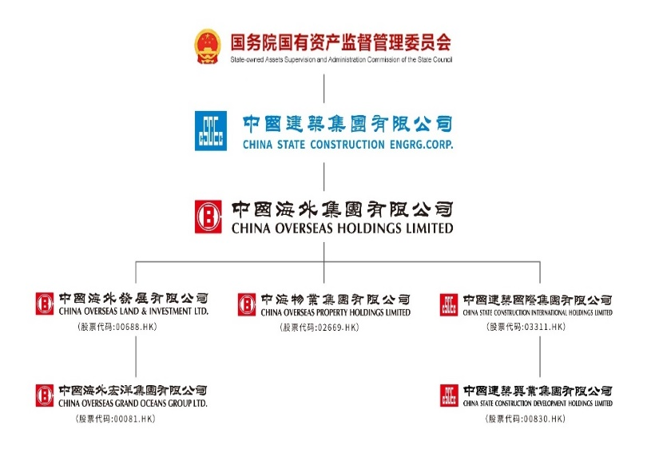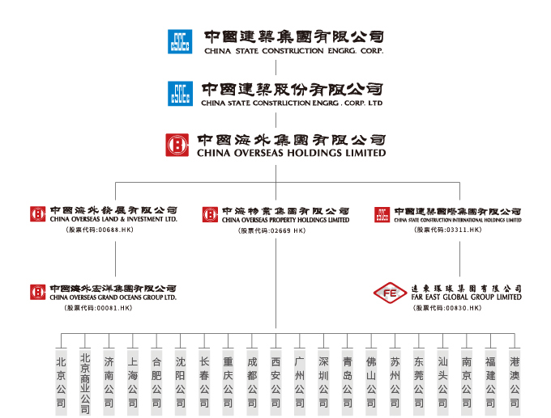
COPSL currently employs over 10,000 staff and manages 260 projects, covering an area of over 12 million square meters. Our services extend beyond private projects to include numerous Government initiatives, currently serving three bureaux, twelve departments, and twenty-two executive bodies. Our advantageous position continues to grow significantly.
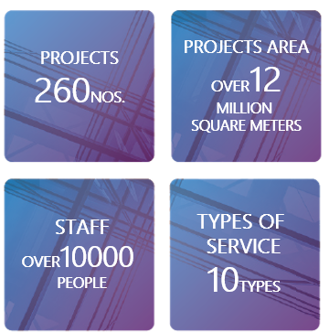
COPSL has been providing Property Management Services to those Venues at a remarkable standard. The properties included, but not limited to the followings:


Educational Facilities
- The Education University of Hong Kong
- The Create of the Hang Seng University of Hong Kong
- Hong Kong Art Centre and Art School Campuses
- Government Accommodation at Landmark South of Hong Kong Arts Development Council
- Korean International School Hong Kong
The Education University
of Hong Kong
- Bethel High School
- University of Macau (Our Groups Company’s project)
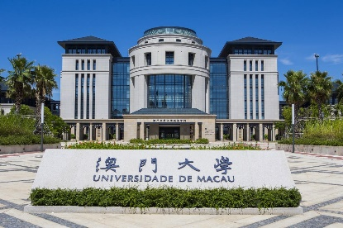
- Macau University of Science and Technology
University of Macau
- Tsinghua Shenzhen International Graduate School
- Remin University of China Tongzhou Campus

Government Complexes and Headquarters Buildings

- Hong Kong Police Headquarters Complex
The Hong Kong Police Headquarters Complex
- Customs Headquarters Building
- The Justice Place and the former French Mission Building
- Housing Authority Head Office
- APB Centre (Office of Architecture Services Department)
- Tuen Mun Siu Lun Government Complex
- Tseng Choi Street Government Services Complex
- Kowloon East Regional Headquarters and Operational Base cum Ngau Tau Kok Divisional Police Station


Cultural and Recreational Facilities
The Justice Place and
the former French Mission Building
- Hong Kong Palace Museum
- Hong Kong Museum of Art
- H6 CONET and 7 Mallory Street
- The City Gallery
- Oil Street Art Space
- Hog Kong Visual Arts Centre

- Kai Tak Cruise Terminal
Chinese People's Lib-eration Army Forces Hong Kong Building
- Sham Shui Po Library


Hong Kong Palace Museum
Kai Tak Cruise Terminal

Leveraging this abundant and directly relevant experience, COPSL possesses the proven expertise, scalable resources, and dedicated commitment necessary to deliver outstanding property management services to the Student Hostel of The University of Hong Kong. We are confident that our demonstrable track record of excellence makes us the strategic and reliable partner of choice for this important contract.


  - Relevant Project Reference

1.2.1 Similar Projects

Project: | Property Services for Po Tin Estate and Fu Tai Estate



Property Services for Po Tin Estate and Fu Tai Estate

Annual Conntract Sum: | HK$61.2M
Contract Period: | 2022/7/1-2027/6/30
Number of Rooms: | 13,801
Client: | Housing Authority

1.2.2 Universities Projects ,….

Project: | Postgraduate and faculty dormitories at the University of Macau (including the W32 Doctoral Building)
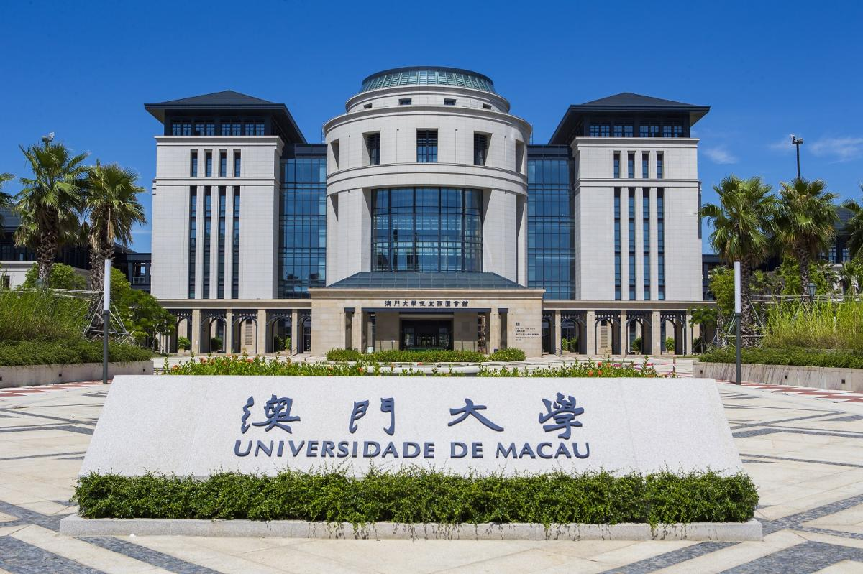

Provision of integrated management services for postgraduate and faculty dormitories at the University of Macau (including the W32 Doctoral Building)

Annual Conntract Sum: | HK$11.8M
Contract Period: | 2019/7/1-2027/6/30
Client: | the University of Macau

  - Duties and Responsibility

The Duties and responsibility of the core personnel are as follow:

Name (Position) | Duties and Responsibility
Property Management Services  YUENG Sheung Chun  Senior Property Manager  (Off-site Senior Managerial Staff for monitoring) | Mr. YUEN Sheung Chun will act as off-site Senior Managerial Staff to provide consultancy services and monitor the overall services delivery to the Student Hostel. He will be responsible for the following:  - Act as consultant of the services delivery  - Attend review meeting with HKU regularly  - Monitor the quality of the services delivery  - Provide support during contingent situations

Name (Position) | Duties and Responsibility
Student Engagement and Community Programming  CHAN Man Hin  Head (Youth Affairs)  (Off-site Support Team) | Mr. CHAN Man Hin will provide off-site professional support to the on-site team. He will be responsible for the following:  - Lead overall project strategy, planning, and management; advise on and decide actions for serious or emergency incidents.  - Report progress and operations to PLK's management and Board.  - Guide and support the team
Student Engagement and Community Programming  CHEUNG Hin Ying  Deputy Head (Youth Affairs)  (Off-site Support Team) | Ms. CHEUNG Hin Ying will provide off-site professional support to the on-site team. She will be responsible for the following:  - Support the Head in daily management and project oversight.  - Allocate resources and provide direction on services and incident response.  - Manage external liaison.

Name (Position) | Duties and Responsibility
NG Hoi Man  Property Manager  (Key Person)  (On-site Team) | Mr. NG Hoi Man will act as the on-site official representative in-charge of the operation and management of the Student Hostel (Operation and Maintenance, including Tenancy Management, and Student Engagement and Community Progamming). He will oversee the property management for the project. He will be responsible for the following:  - Act as a communication point with Hostel Warden/ HKU  - Responsible for the overall management in all aspects at the Student Hostel, supervising performance of frontline staff and the services contractors;  - Develop and ensure the smooth execution of various service procedures;  - Handle and respond to emergencies, lead the emergency response team, and report to the Hostel Warden/ HKU;  - Review and approve all service data and reports;  - Submit work reports and provide suggestions and measures for service improvement to the Hostel Warden/ HKU;  - Ensure all staff adhere to established work procedures and provide necessary work guidelines;  - Inspect and review the work of subordinates and be responsible for their performance evaluation;  - Handle issues at Hostel Warden/ HKU in a timely manner according to the regulations (and other rules), attempting to immediately stop disputes, prevent violations and disruptive behavior, etc., and contact the Hostel Warden/ HKU in serious cases; and  - Any other related tasks as instructed by the Hostel Warden/ HKU.
Report to HKU/ Hostel Warden, and our Senior Property Manager

Name (Position) | Duties and Responsibility
MA Dan  Senior Property Officer  (On-site Team) | Mr. MA Dan will act as deputy on-site official representative in-charge of the operation and management of the Student Hostel (Operation and Maintenance, including Tenancy Management, and Student Engagement and Community Programming). He will deploy frontline staff for duties and supervise their performance, and report to the Property Manager. He will be responsible for the following:  - Assist Property Manager for the overall management of all aspects of Student Hostel, supervising performance of frontline staff and the services contractors;  - Coordinate relationships between residents, services contractors, etc. to ensure smooth operation;  - Handle and respond to emergencies, lead the emergency response team, and report to the Property Manager;  - Organize and maintain all service data and reports;  - Submit work reports to the Property Manager;  - Ensure all staff adhere to established work procedures and provide necessary work guidelines;  - Inspect the work of subordinates and be responsible for their performance evaluation;  - Handle issues at Contract Venue in a timely manner according to the regulations (and other rules), attempting to immediately stop disputes, prevent violations and disruptive behavior, etc., and contact the Property Manager;  - Lead the Property Assistant to provide Tenancy Management Services and report to the Property Manager; and  - Any other related tasks as instructed by the Property Manager
Report to Property Manager

Name (Position) | Duties and Responsibility
TAM Kam Chu  Property Officer  (On-site Team) | Ms. TAM Kam Chu will assisting the Property Manager and Senior Property Officer to handle the operation and management of the Student Hostel (Operation and Maintenance) He will be responsible for the following:  - assist the Property Manager and Senior Property Officer to ensure smooth day-to-day operation and maintenance of the Student Hostel;  - Coordinate for the security, cleaning, waste disposal, pest control, building services, maintenance services and other related services for the Accommodation by liaising with relevant parties on the provision of these services as necessary;  - Deploy and supervise frontline staff such as security guards, cleaners, gardeners;  - Ensure the smooth execution of various service procedures;  - Ensure all staff adhere to established work procedures and provide necessary work guidelines;  - Coordinate the work of subordinates;  - Handle issues at Contract Venue in a timely manner according to the regulations (and other rules), attempting to immediately stop disputes, prevent violations and disruptive behavior, etc., and contact the Senior Property Officer  - Lead the Security Team and Cleaning Team to provide relevant operational services and report to the Senior Property Officer;  - Any other related tasks as instructed by the Senior Property Officer;  - Respond to emergencies, lead the emergency response team, and report to the Client;  - Prepare all service data and reports;  - Submit work reports to the Senior Property Officer; and  - Any other related tasks as instructed by the Senior Property Officer
Report to Senior Property Officer

Name (Position) | Duties and Responsibility
Mr WONG Chun Chung  Technical Officer  (On-site Team) | Mr WONG Chun Chung will be the in-charge of the technical team, assisting the Property Manager and Senior Property Officer to handle matters related to repair and maintenance and provide technical support to the Student Hostel. He will be responsible for the following:  - Arrange contractors or technicians to make, install or purchase, or cause to be made, installed or purchased, and carry out, all repairs to and replacements of the FF&E;  - Arrange and supervise the works carried out by contractors and technicians to maintain the Accommodation in good condition and repair and in accordance with the Agreement including the Operating Standards and if applicable, the CEDARS requirements.  - Prepare the yearly and monthly work plan, and to arrange the inspection work which needs to be carried out in a systematic order;  - Should any irregularities are found, look into the situation and work out a remedial action plan. After approval of the plan, arrange contractor to carry out repair work; and  - Engage appropriate contractors to perform routine maintenance at least once every 12 months or in accordance with relevant statutory requirements, whichever is more stringent thereby ensuring all systems, installations, and facilities adhere to statutory, safety, and user requirements, while minimizing operational downtime and disruptions at the Accommodation;  - Monitor the stock of spare parts and arrange to order when needed; and  - Any other tasks related to repair and maintenance required by the Property Manager.
Report to Senior Property Officer

Name (Position) | Duties and Responsibility
LEE Tak Wai  (Service Manager, Student Engagement and Community Programming)  (On-site Team) | Mr. Lee Tak Wai is a Registered Social Worker and will be the Project-in-charge on- and off-site for the hostel community services. He will oversee the planning and management for the hostel community services for the project. He will act as the Deputy of the Project Manager in case Ms Chan Siu Yu on leave. He will be responsible for the followings:  - Provide timely counselling and advisory support to exchange hostel youth in need, and make appropriate referrals as necessary.  - Respond immediately to serious incidents and emergencies.  - Oversee the overall on-site service operations, including activity planning, resource management, and service quality monitoring.  - Supervise the day-to-day implementation of services and collaborate with the team to discuss service content and direction.  - Provide guidance and professional advice to the team to ensure the quality and smooth execution of activities.  - Lead the team in conducting service quality and performance reviews, and formulate plans for continuous improvement and optimisation.  - Maintain close and positive relationships with partners.  - Manage personnel and project-related administrative tasks.
Report to Property Manager

Name (Position) | Duties and Responsibility
CHAN Siu Yu  (Project Manager, Student Engagement and Community Programming)  (On-site Team) | Ms. CHAN Siu Yu is a Registered Social Worker and will lead the hostel community service team onsite and be responsible for the followings:  - Provide timely counselling and advisory support to youth staying in exchange hostels as needed, and make appropriate referrals when necessary  - Responsible for the implementation and management of designated projects, coordinating various service activities including event dates, venue arrangements and support, manpower deployment, etc.  - Ensure all activities are carried out as planned and that pre-set goals are achieved  - Provide guidance and professional advice to the team to ensure service quality and smooth execution of activities  - Maintain close and positive working relationships with partner organisations  - Liaise and coordinate with relevant parties and stakeholders when organising community activities  - Discuss and formulate annual plans and budget with the team on a yearly basis
Report to Service Manager

Name (Position) | Duties and Responsibility
LAM Tsz Ying  (Project Officer, Student Engagement and Community Programming)  (On-site Team) | Ms. LAM Tsz Ying will be the Chief Project Officer onsite and provide full support to the Service Manager and Project Manager the followings:  - Interact directly with youth and assist in the planning and execution of activities  - Prepare necessary materials and equipment for activities  - Liaise with external parties, including hostel residents, volunteers, and service providers  - Provide administrative support, including document preparation, meeting coordination, recruitment, and financial arrangements  - Manage resources, including supplies and assets, and maintain relevant records  - Assist in promotion and publicity efforts  - Handle team document organisation, data entry, and database maintenance  - Manage service procurement  - Prepare activity and financial reports
Report to Project Manager

Name (Position) | Duties and Responsibility
LO Chun Leung  (Project Officer, Student Engagement and Community Programming)  (On-site Team) | Mr. Lo Chun Leung will provide full support to the Managers and the Chief Officer the followings onsite:  - Interact directly with youth and assist in the planning and execution of activities  - Prepare necessary materials and equipment for activities  - Liaise with external parties, including hostel residents, volunteers, and service providers  - Provide administrative support, including document preparation, meeting coordination, recruitment, and financial arrangements  - Manage resources, including supplies and assets, and maintain relevant records  - Assist in promotion and publicity efforts  - Handle team document organisation, data entry, and database maintenance  - Manage service procurement  - Prepare activity and financial reports
Report to Project Manager


  - Organization Chart
1.4.1 Organization Structure
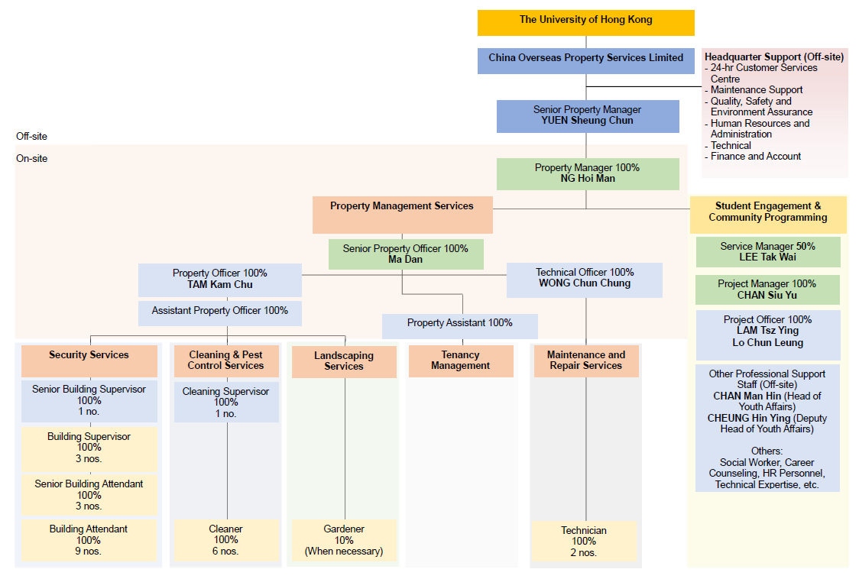
1.4.2 Relevant Manpower Required
1.4.3 Percentage of Each Team Member’s Input under their Respective Disciplines

Position | Quantity of Staff | Percentage input
On-site in charge of operation and management services of the Accommodation
Property Manager | 1 | 100%
Overall Property Management Service, including but not limited to Tenancy Management, Customer Services, and Quality, Health, Safety and Environmental Service
Senior Property Officer | 1 | 100%
Property Officer | 1 | 100%
Assistant Property Officer | 1 | 100%
Property Assistant | 1 | 100%
Student Engagement & Community Programming
Service Manager | 0.5 | 50%
Project Manager | 1 | 100%
Project Officer | 2 | 100%
Other Professional Supporting Staff (i.e. social worker, career counselor, Public relations, etc.) | When necessary
Repair and Maintenance Service
Technical Officer | 1 | 100%
Technician | 2 | 100%
Security and Carparking Service
Senior Building Supervisor | 1 | 100%
Building Supervisor | 3 | 100%
Senior Building Attendant | 3 | 100%
Building Attendant | 9 | 100%
Cleansing, Pest Control, Gardening Service
Cleaning Supervisor | 1 | 100%
Cleaner | 6 | 100%
Gardener | When necessary

1.4.4 Relevant Reporting Lines

The University of Hong Kong
The Operator
(China Overseas Property Services Limited)
Property Manager
Operation and Maintenance Services
Property Management Services |  |  |  |  | Student Engagement & Community Programming
Senior Property Officer |  |  |  |  | Service Manager
Security and Carparking Services | Cleansing and Pest Control | Gardening Service | Tenancy Management Service | Repair and Maintenance Service | Project Manager
Property Officer |  |  |  | Technical Officer | Project Officer
Assistant Officer
 |  |  | Property Assistant
Senior Building Supervisor | Cleaning Supervisor
Building Supervisor
Senior Building Attendant
Building Attendant | Cleaner | Gardener |  | Technician

  - CV of Property Management Services Provider
THE key person FOR THE PROPERTY MANAGEMENT TEAM

Staff  assigned to this contract  (name) | Key person | Part 1 – Qualification |  | Part 2 – Experience
 |  | Professional Qualifications | Date of award (mm/yy) | Year of Post Qualification Experience in the capacity of the Position in this proposal | Employment Period
 |  |  |  |  | Company | Post | From  (dd/mm/yy) | To  (dd/mm/yy)
Property Management Services Provider
NG Hoi Man | Property Manager  (Key Person) | Professional Diploma in Housing Management  The University of Hong Kong (SPACE) | 2019 | - A minimum of 2 years’ post-professional qualification experience  - In possession of, at least a Higher Diploma (or equivalent) in any discipline  - In possession of, at least Property Management Practice Licence (Tier 2) from the Property Management Services Authority (PMSA) | China Overseas Property Services Limited | Property Manager I  of Po Tin Estate (exceed HK$40 million per annum) | 2025 | Present
 |  | Property Management Practitioner (Tier 1) Licence | 2023 |  | China Overseas Property Services Limited | Property Manager I  of Po Tin Estate (exceed HK$40 million per annum) | 2025 | 2025
 |  | Member of the Hong Kong Institute of Housing | 2022 |  | China Overseas Property Services Limited | Property Manager II  of Po Tin Estate (exceed HK$40 million per annum) | 2023 | 2025
 |  |  |  |  | China Overseas Property Services Limited | Assistant Property Manager  of Po Tin Estate (exceed HK$40 million per annum) | 2022 | 2023
 |  |  |  |  | China Overseas Property Services Limited | Assistant Property Manager  of Shan King Estate | 2021 | 2022
 |  |  |  |  | Harriman Property Management Limited | Estate Officer | 2020 | 2021
 |  |  |  |  | MTR | Property Officer | 2019 | 2020
 |  |  |  |  | Pioneer Management Limited | Property Service Officer | 2018 | 2019
 |  |  |  |  | Sunbase International Properties Management Limited | Property Service Officer | 2015 | 2018
 |  |  |  |  | Creative Property Services Consultants Limited | Property Officer | 2014 | 2015

Staff  assigned to this contract  (name) | Key person | Part 1 – Qualification |  | Part 2 – Experience
 |  | Professional Qualifications | Date of award (mm/yy) | Year of Post Qualification Experience in the capacity of the Position in this proposal | Employment Period
 |  |  |  |  | Company | Post | From  (dd/mm/yy) | To  (dd/mm/yy)
Property Management Services Provider
Ma Dan | Senior Property Officer | Diploma in Hotel Management  Foshan Polytechnic | 2018 | - A minimum of 3 years’ post-professional qualification experience, and at least 1 years is at rank of managerial and supervisory level  - In possession of, at least a Higher Diploma (or equivalent) in any discipline;  - In possession of, at least a Property Management Practice Licence (Tier 2) from the Property Management Services Authority (PMSA); | China Overseas Property Services Limited | Property Manager  Of University of Macau N1 Juxian Building (University) | 2023 | Present
 |  | Certificate in Golden Key Butler Service | 2023 |  | China Overseas Property Services Limited | Property Manager  Of University of Macau postgraduate dormitory (University) | 2019 | 2023
 |  | Certified Intermediate Tea Artist |  |  | Home Inn Business Hotel | Lobby Deputy Manager | 2018 | 2019
 |  | Certificate for Red Cross First Aider | 2024

Staff  assigned to this contract  (name) | Key person | Part 1 – Qualification |  | Part 2 – Experience
 |  | Professional Qualifications | Date of award (mm/yy) | Year of Post Qualification Experience in the capacity of the Position in this proposal | Employment Period
 |  |  |  |  | Company | Post | From  (dd/mm/yy) | To  (dd/mm/yy)
Property Management Services Provider
TAM Kam Chu | Property Officer | Professional Diploma in Housing Management  The University of Hong Kong (SPACE) | 2025 | - A minimum of 2 years’ post-professional qualification experience  - In possession of, at least a Higher Diploma (or equivalent) in any discipline  - In possession of, at least Property Management Practice Licence (Tier 2) from the Property Management Services Authority (PMSA) | China Overseas Property Services Limited | Property Officer  of Po Tin Estate (exceed HK$40 million per annum) | 2025 | Present
 |  | Property Management Practitioner (Tier 2) Licence | 2024 |  | China Merchants Shipping & Enterprises Company Limited | Assistant Property Officer | 2018 | 2025

Staff  assigned to this contract  (name) | Key person | Part 1 – Qualification |  | Part 2 – Experience
 |  | Professional Qualifications | Date of award (mm/yy) | Year of Post Qualification Experience in the capacity of the Position in this proposal | Employment Period
 |  |  |  |  | Company | Post | From  (dd/mm/yy) | To  (dd/mm/yy)
Property Management Services Provider
WONG Chun Chung | Technical Officer | Vocational Certificate for Electrical Installation Technicians  IVE (Haking Wong) for the Vocational Training Council | 2008 | - A minimum of 3 years’ post-professional qualification experience  - At least have a Diploma or Higher Certificate in Building or Building Studies or equivalent, or above | CHINA OVERSEAS PROPERTY SERVICES LIMITED | Building Services Engineer | 5/2018 | Present
 |  |  |  |  | HARRIMAN PROPERTY MANAGEMENT LIMITED | Building Engineer | 5/2017 | 5/2018
 |  |  |  |  | CHINA OVERSEAS PROPERTY SERVICES LIMITED | Engineer | 9/2016 | 5/2017
 |  | Higher Diploma in Electrical Engineering  IVE (Haking Wong) for the Vocational Training Council | 2013 |  | HONG YIP SERVICE COMPANY LTD. | Technical Officer | 12/2015 | 5/2017
 |  |  |  |  | VCC Land Limited (V HOTELS & SERVICES APARTMENTS) | Repair & Maintenance Supervisor | 12/2014 | 9/2015
 |  | Certificate of Registration of Electrical Worker（B0） | 2021 |  | HONG YIP SERVICE COMPANY LTD. | Technical Officer | 4/2014 | 11/2014
 |  | Construction Industry Safety Training Certificate | 2021 |  | SINO ESTATES MANAGEMENT LTD. | Maintenance Supervisor | 10/2012 | 8/2012
 |  |  |  |  | CITYBASE PROPERTY MANAGEMENT LTD. | Technician | 4/2011 | 8/2012
 |  |  |  |  | SINO ESTATES MANAGEMENT LTD. | Technician | 11/2008 | 4/2011

Staff  assigned to this contract  (name) | Key person | Part 1 – Qualification |  | Part 2 – Experience
 |  | Professional Qualifications | Date of award (mm/yy) | Year of Post Qualification Experience in the capacity of the Position in this proposal | Employment Period
 |  |  |  |  | Company | Post | From  (dd/mm/yy) |  | To  (dd/mm/yy)
Student Engagement and Community Programming
LEE Tak Wai | Project Service Manager  (Key Person) | - Registered Social Worker  - Projective Drawing Analyst  - Certificate of Accredited Mediator  - Personality Dimensions® Facilitator (Level 1)  - Everything DiSC® Certified Facilitator  - Trained facilitator of LEGO® SERIOUS PLAY® method and materials  - LEGO®-based therapy facilitator |  | - A minimum of 10 years’ post-professional qualification experience | Po Leung Kuk | Service Manager (Youth Affairs) |  | 2021 |  | Present
 |  |  |  |  |  | Supervisor (Children and Youth) |  | 2010 |  | 2021
 |  |  |  |  |  | Social Worker |  | 2008 |  | 2010

Staff  assigned to this contract  (name) | Key person | Part 1 – Qualification |  | Part 2 – Experience
 |  | Professional Qualifications | Date of award (mm/yy) | Year of Post Qualification Experience in the capacity of the Position in this proposal | Employment Period
 |  |  |  |  | Company | Post | From  (dd/mm/yy) |  | To  (dd/mm/yy)
Student Engagement and Community Programming
CHAN Siu Yu | Project Manager | - Registered Social Worker  - Projective Drawing Analyst  - Personality Dimensions Facilitator (Level 1)  - Master Practitioner of Neuro Linguistic Programming |  | - A minimum of 8 years’ post-professional qualification experience | Po Leung Kuk Student Guidance and Support Services | School social worker |  | 2024 |  | Present
 |  |  |  |  | YWCA Jockey Club Family Wellness Centre | Social worker (part-time) |  | 2024 |  | 2024
 |  |  |  |  | Centre for Restoration of Human Relationships | School social worker (supply) |  | 2023 |  | 2023
 |  |  |  |  | SRBCEPSA Lu Kwong Fai Memorial School | School social worker (part-time) |  | 2016 |  | 2023
 |  |  |  |  | HKFYG Student Guidance Team | Youth Work Officer |  | 2012 |  | 2013
 |  |  |  |  | HKFYG Jockey Club Verbena Youth SPOT | Youth Work Officer |  | 2008 |  | 2012

Staff  assigned to this contract  (name) | Key person | Part 1 – Qualification |  | Part 2 – Experience
 |  | Professional Qualifications | Date of award (mm/yy) | Year of Post Qualification Experience in the capacity of the Position in this proposal | Employment Period
 |  |  |  |  | Company | Post | From  (dd/mm/yy) |  | To  (dd/mm/yy)
Student Engagement and Community Programming
LAM Tsz Ying | Project Officer | - Challenge Course Association of HK, China  - (Low Event and High Event) Level 1 Technical Certificate and Assistant Instructor  - Life Development Institute (Career Development Advisor (NCDA + CCSP))  - Certificate in First Aid Course – Hong Kong St. John Ambulance  - Mental Health First Aid - The Mental Health Association of Hong Kong |  | - A minimum of 4 years’ post-professional qualification experience | Po Leung Kuk | Project Officer |  | 2025 |  | Present

Staff  assigned to this contract  (name) | Key person | Part 1 – Qualification |  | Part 2 – Experience
 |  | Professional Qualifications | Date of award (mm/yy) | Year of Post Qualification Experience in the capacity of the Position in this proposal | Employment Period
 |  |  |  |  | Company | Post | From  (dd/mm/yy) |  | To  (dd/mm/yy)
Student Engagement and Community Programming
LO Chun Leung | Project Officer | - N/A | N/A | - At least 4 years’ post-professional qualification experience | Po Leung Kuk | Youth Worker (Youth Oasis) |  | 2024 |  | Present
 |  |  |  |  | Excellent Global Business Limited | Senior Sales and Marketing Officer |  | 2022 |  | 2024
 |  |  |  |  | Empire Hotel Hong Kong | Senior Events and Sales Executive  Events and Sales Executive  Events and Sales Executive (Joined as) |  | 2017 |  | 2022

